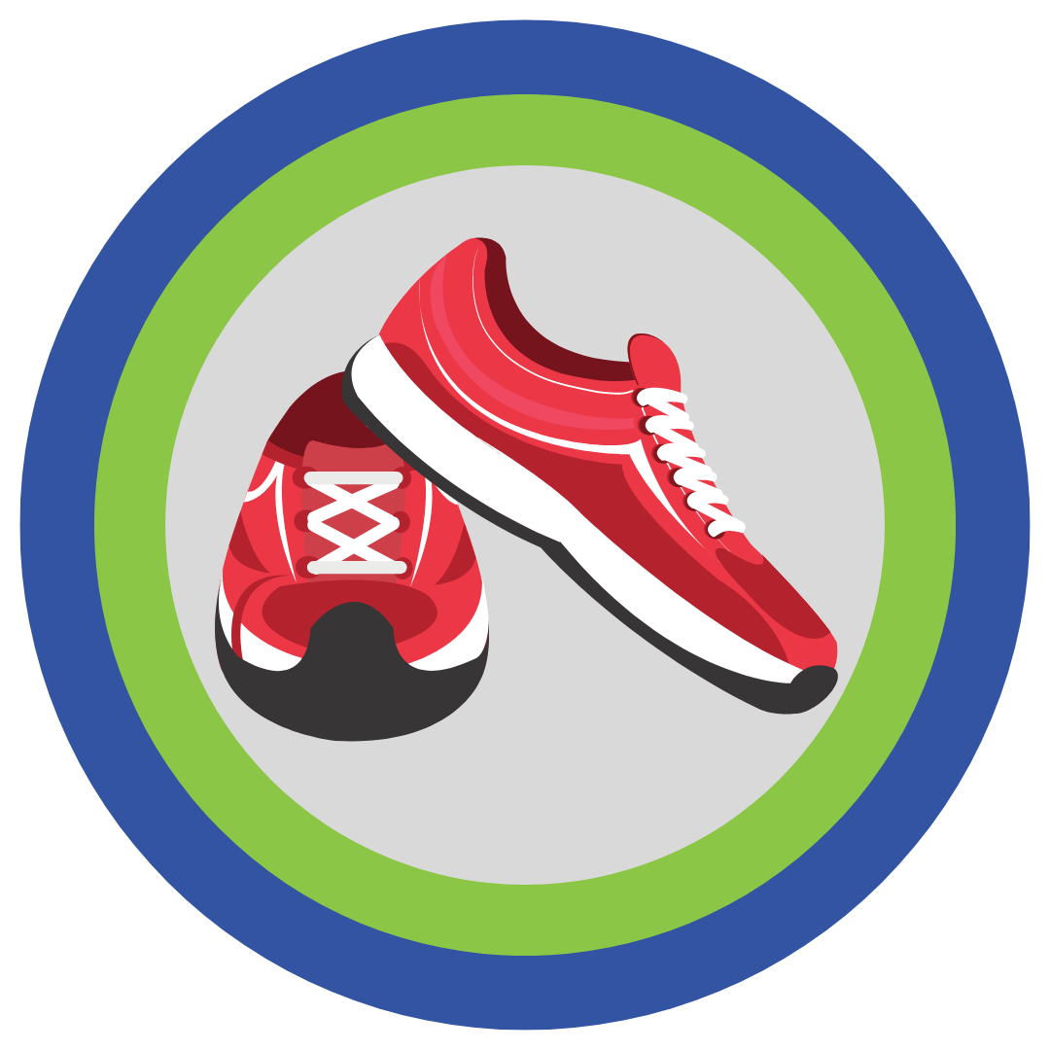
Kilometers For Kids

10th Annual Run/Walk for Building Mental & Emotional Wellness In Northumberland County
Participant Name:
Dear Potential Sponsor,
I am participating in the Kilometers for Kids walk/run - all proceeds will go to Rebound Child & Youth Services, a not-for-profit charitable child and youth organization that provides free mental health counselling, parenting support through the Family Wellness Hub, youth justice diversion services, and youth homelessness prevention programs.
You can sponsor me for any amount of your choice. Please make cheques payable to Rebound Child & Youth Services. All contributions of $20+ are tax-deductible.
Thank you!
 | Name, address, phone number, email address | Pledge ($) | Amount Collected from Sponsor ($)
1
2
3
4
5

(More entries on the back)

Participants:
Please bring this form & funds raised the day of the run.

 | Name, address, phone number, email address | Pledge ($) | Amount Collected from Sponsor ($)
6
7
8
9
10

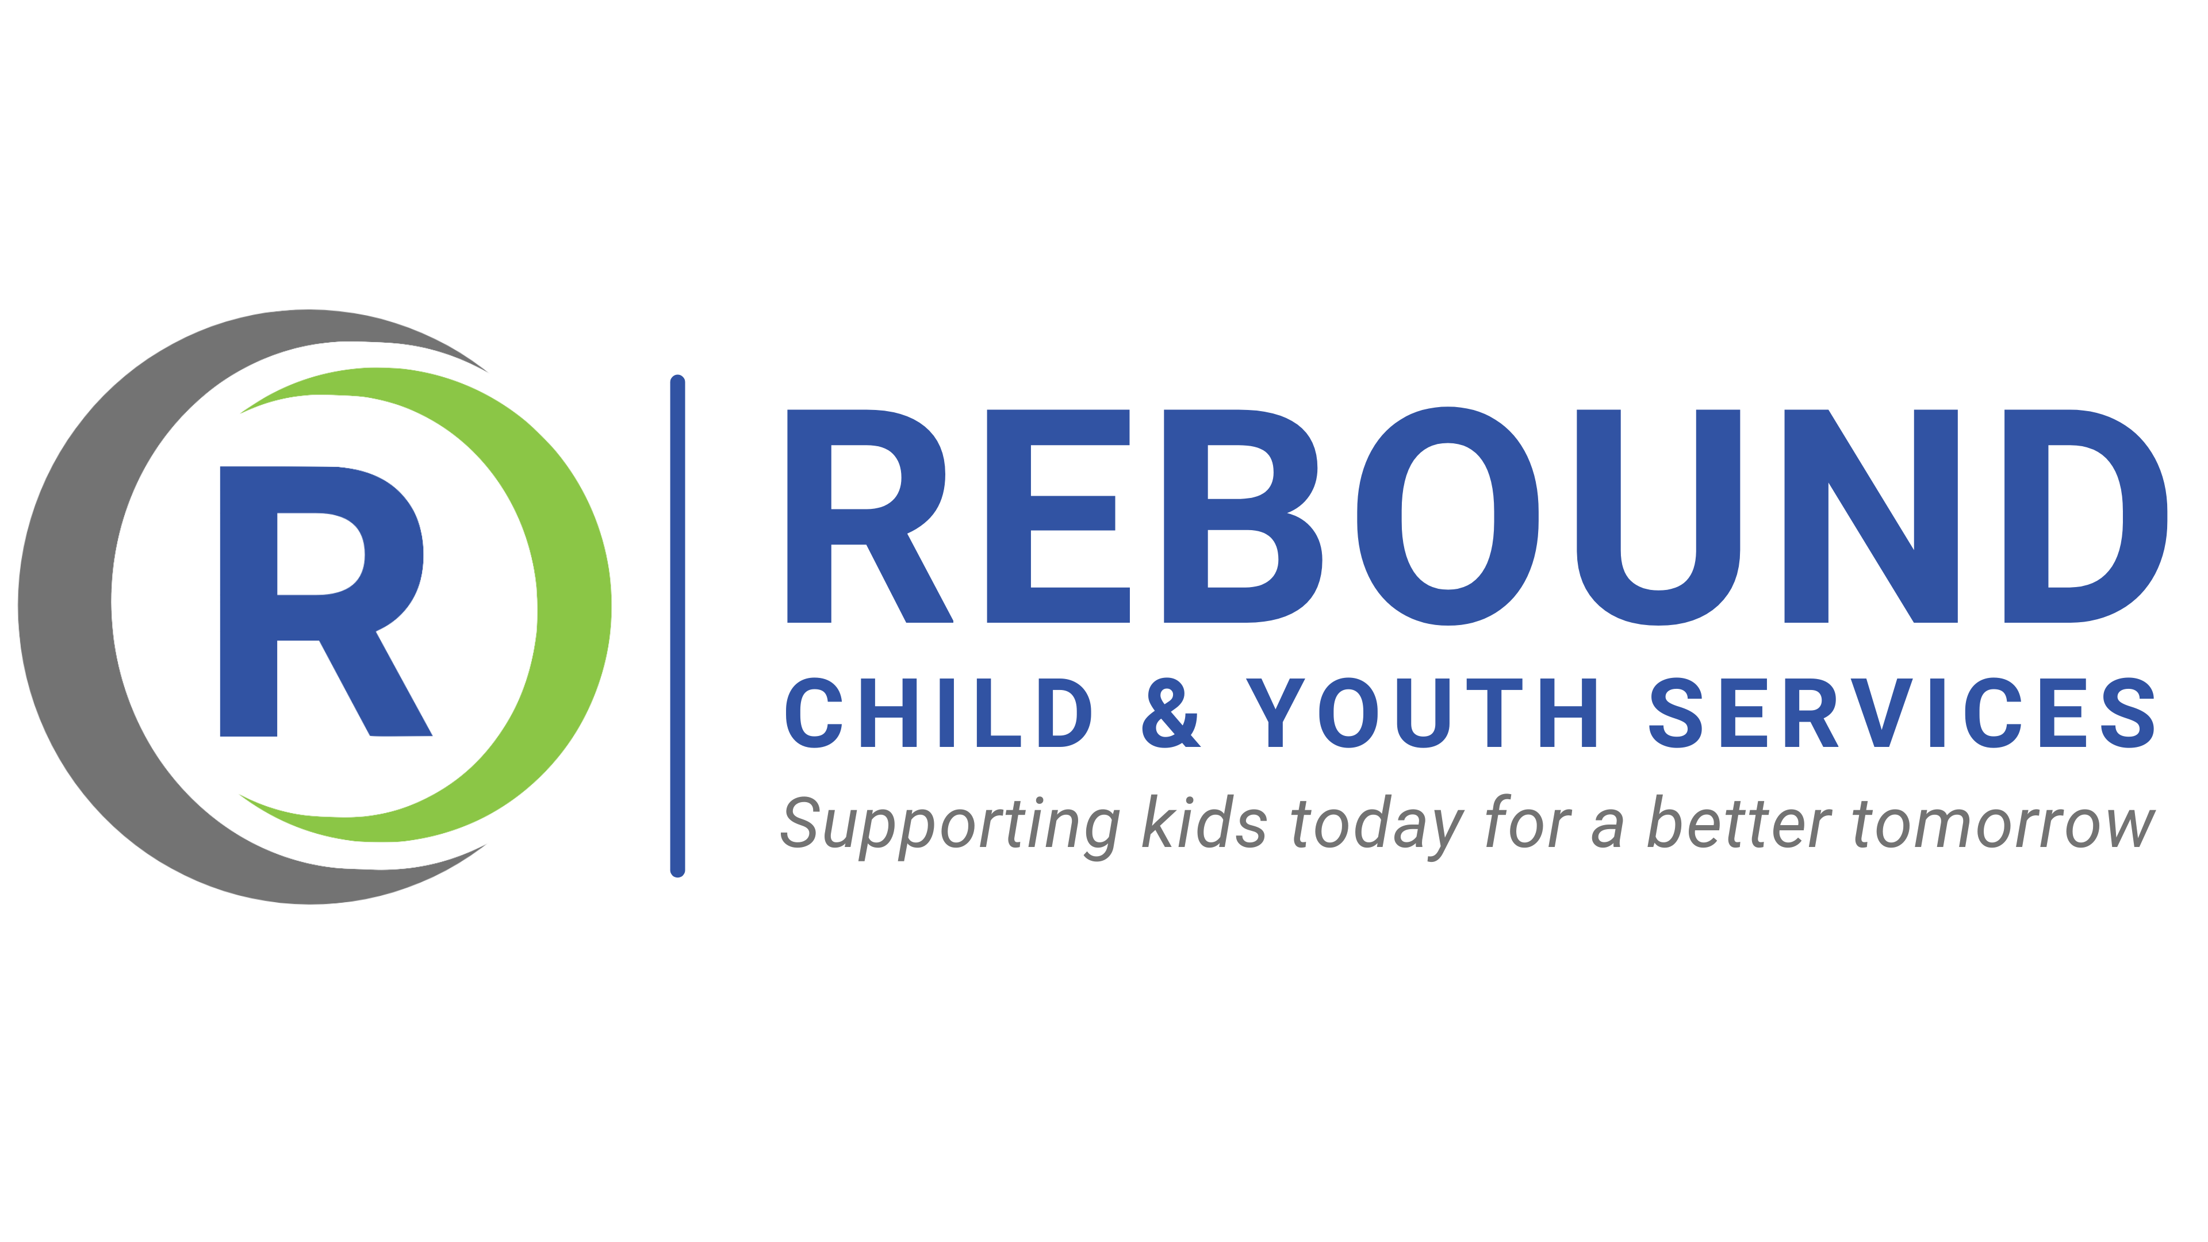
Thank you for your support!

