Kilometers for Kids 2024
5km Route
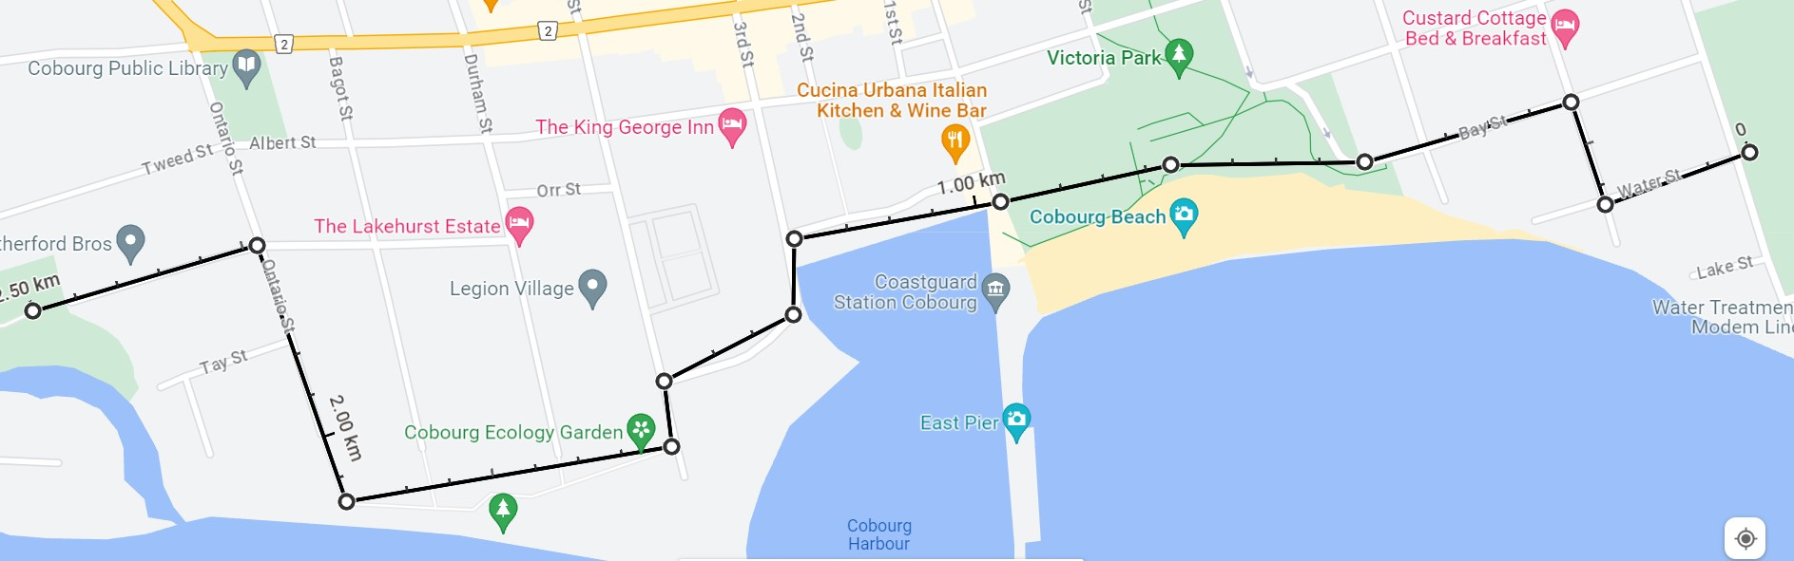

Start/finish – Donegan Park
Water St to Henry St
Left onto Bay St, follow Waterfront and Harbour to Hibernia St
Along Boardwalk to Ontario St
Ontario St to Clyde St to Peace Park – turning at the park to follow the route back to Donegan Park

