Kilometers for Kids 2024 – East Route
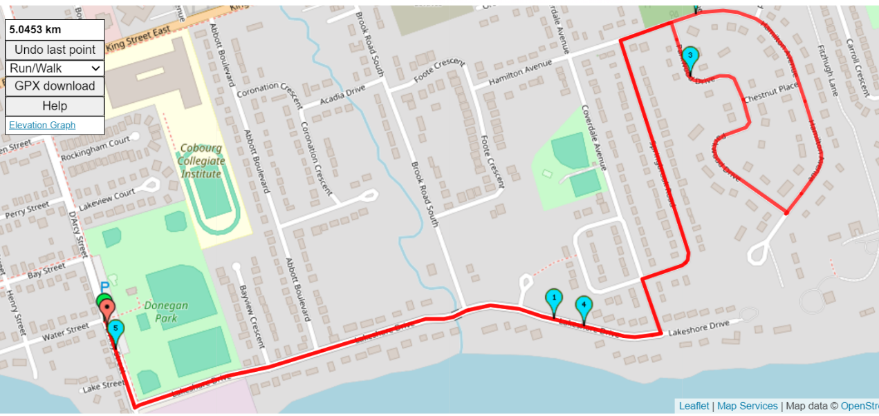
2nd half of 10km run

Have participants do 5k route that heads west to the Peace Park.
When they get back to Donegan Park they do the east 5k route

East on Lakeshore
Left on Coverdale
Right on Springbrook
Right onto Hamilton
Right onto Parkwood Drive
Left onto Hamilton
Left onto Springbrook
Left onto Coverdale
Right onto Lakeshore
Right onto Darcy.

